the convo started:
me: hi
her: umm hello
me: [this was a test to see if it was really ChocoTrufflez] did u get the concert tickets yet?
her: wat tickets?
me: get off of my friends account, hacker.
you people are really scum. shes not an ss, y did you bother her?
her: I don’t hav to get stardollars
me: wat do you mean?
[it was something like that]
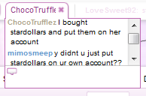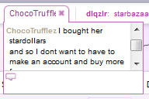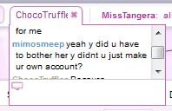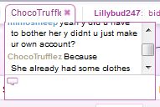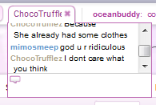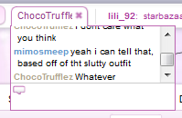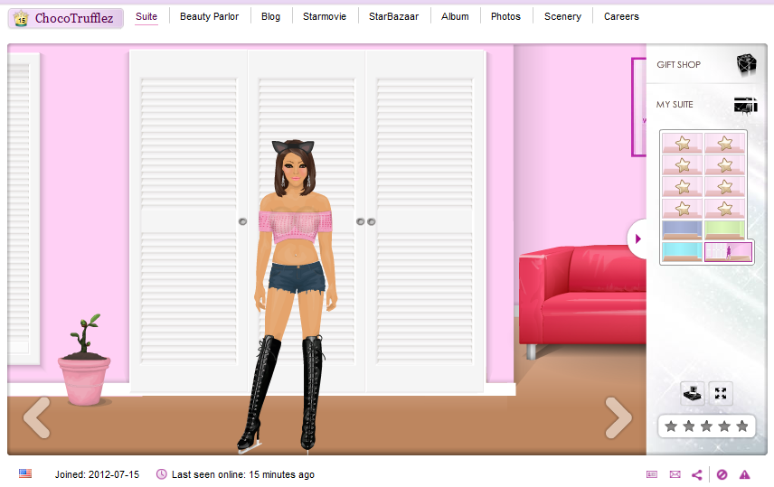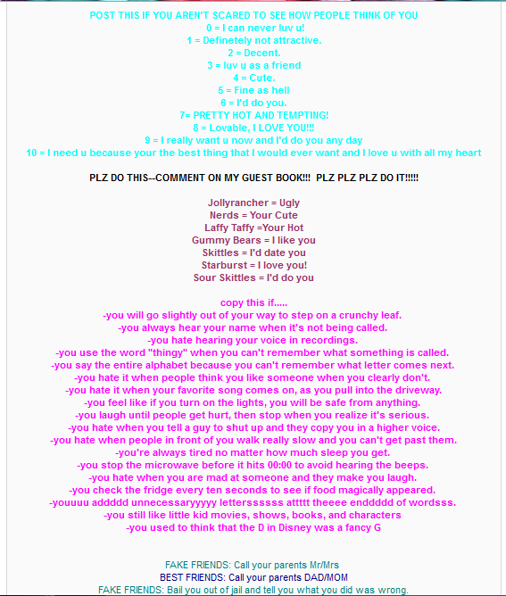
Revealing outfit, which my friend would never wear, even online.
All of this was added by the hacker. A lot of it is disgusting, like how she asks people to rate her and if they’d “do her.” Ich.

